CodeSentinel V1
Subtitle: Portable AI-Powered Debugging, Verification, and Student Utility Assistant for CS Students

Introduction
Computer science students frequently face challenges in understanding programming errors and debugging code effectively. While modern AI tools can provide quick solutions, they often encourage passive learning by directly giving answers instead of helping students think through problems.

CodeSentinel is designed as a portable AI-powered debugging trainer that promotes active learning. It provides guided debugging assistance, encourages users to identify and fix errors themselves, and tracks their debugging performance over time. The system integrates a web-based interface with an ESP32-based hardware module that provides real-time visual and physical feedback, creating an interactive and engaging learning experience.

Problem Statement
CS students commonly face the following issues:
- difficulty understanding the root cause of programming errors
- over-reliance on AI tools that provide direct solutions
- lack of structured guidance while debugging
- inability to track and improve debugging skills over time
- absence of an interactive system that combines learning with real-time feedback
There is a need for a system that teaches debugging as a skill, rather than simply solving problems.

Proposed Solution
CodeSentinel is a focused AI-based debugging assistant with two main modes:
- Guided Debug Mode (Learning Mode)
  - AI analyzes the code but does not immediately provide the answer
  - Users are asked to identify the faulty line and error type
  - AI provides step-by-step hints based on user responses
  - Encourages logical thinking and problem-solving
- Direct Fix Mode (Solution Mode)
  - AI provides the corrected code and explanation directly
  - Useful for quick reference and learning after attempts
The system includes a real-time synchronization mechanism between the web application and an ESP32 hardware unit using WiFi-based HTTP communication. The hardware module reflects user performance through LEDs, OLED display, and buzzer alerts.

Main Objectives
- help students learn debugging through guided interaction
- reduce dependency on direct AI-generated solutions
- improve logical thinking and error analysis skills
- provide real-time feedback using hardware integration
- track and evaluate user debugging performance

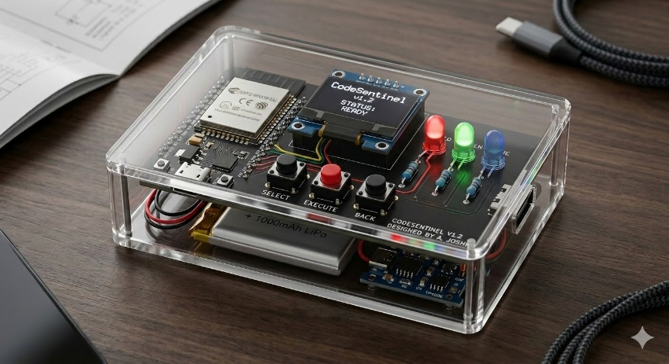
Core Features
- Guided Debugging Interaction System
- Direct Code Fix Mode
- AI-Based Error Analysis (syntax, logic, runtime)
- Step-by-Step Hint Mechanism
- Debugging Performance Tracking System
- Real-Time Web-to-Device Synchronization
- OLED Display for live status and feedback
- LED Indicators for response feedback
- Buzzer alerts for critical outcomes

How the System Works
- The user opens the web interface and selects a mode (Debug or Fix).
- The user inputs code or error logs.
- The backend processes the input using an AI API.
In Debug Mode:
- The system asks the user:
  - which line is incorrect
  - what type of error it is
- The user responds
- The system evaluates the response and:
  - gives hints if incorrect
  - progresses to deeper steps if correct
- The final solution is revealed only after multiple attempts or user request
In Fix Mode:
- The system directly provides corrected code and explanation
- The backend updates a shared device state.
- The ESP32 device polls this state over WiFi and updates:
  - OLED display (short messages, status, score)
  - LEDs (correct, wrong, hint, failure)
  - buzzer (for important alerts)

Hardware Components
- ESP32
- 4 LEDs or red/green/yellow status LEDs
- resistors
- 0.96 inch OLED display
- buzzer
- push buttons
- battery
- charging module
- micro USB cable for programming
- jumper wires and breadboard or PCB later

Software Components
- Python backend (Flask or FastAPI)
- HTML, CSS, JavaScript frontend
- AI API integration (e.g., Gemini)
- Arduino IDE for ESP32 programming
- JSON-based communication between backend and device

System Architecture
- Web Interface → User interaction
- Backend → AI processing and state management
- ESP32 → polls backend and reflects system state
Communication is achieved using HTTP polling, ensuring simplicity and reliability for the prototype.

Why the Project is Innovative
- focuses on teaching debugging instead of providing answers
- introduces interactive AI-guided learning flow
- integrates real-time hardware feedback with software system
- tracks and analyzes user debugging performance
- creates a hybrid learning environment (digital + physical)

Target Users
- computer science students
- beginners learning programming
- students preparing for coding exams and labs
- learners who want to improve debugging skills

Applications
- debugging classroom assignments
- understanding coding mistakes in labs
- checking suspicious text messages or scam screenshots
- quickly accessing useful student tools
- using AI as a learning assistant instead of only an answer generator

Future Scope
- adaptive difficulty based on user performance
- support for multiple programming languages
- advanced analytics and progress visualization
- offline AI model integration
- mobile application support
- OTA updates for ESP32 device
- multi-user system with profiles

Conclusion
CodeSentinel is a focused and practical system that transforms debugging from a passive activity into an interactive learning process. By combining AI guidance, performance tracking, and real-time hardware feedback, it helps students develop stronger problem-solving skills and a deeper understanding of programming errors. The system provides a unique blend of software intelligence and physical interaction, making debugging more engaging, structured, and effective.

